**Natural Language Processing of E-Books**

#### A MINI PROJECT REPORT

**18CSC305J - ARTIFICIAL INTELLIGENCE**

Submitted by

#### Lakshmi Nikitha [RA2111003011810] Naga Sindhu [RA2111003011836]

#### Venkata Krishna[RA2111003011841]

Under the guidance of

**Dr. Lubin Balasubramanian**

Assistant Professor, Department of Computing Technologies

***in partial fulfillment for the award for the degree***

***of***

**BACHELOR OF TECHNOLOGY**

in

**COMPUTER SCIENCE ENGINEERING**

of

**FACULTY OF ENGINEERING AND TECHNOLOGY**



S.R.M. Nagar, Kattankulathur, Chengalpattu District

**MAY 2024**

SRM INSTITUTE OF SCIENCE AND TECHNOLOGY

(Under Section 3 of UGC Act, 1956)

## BONAFIDE CERTIFICATE

Certified that Mini project report titled **“Natural Language Processing of E-books”** is the bonafide work of **Lakshmi Nikitha (RA2111003011810), Naga Sindhu (RA2111003011836), Venkata Krishna (RA2111003011841)** who carried out the minor project under my supervision. Certified further, that to the best of my knowledge, the work reported herein does not form any other project report or dissertation on the basis of which a degree or award was conferred on an earlier occasion on this or any other candidate.

## SIGNATURE

Dr. Lubin Balasubramanian

Assistant Professor

Department of Computing Technologies

# ABSTRACT

This report delves into the application of Natural Language Processing (NLP) techniques for the analysis of e-books, aiming to extract meaningful insights and enhance user experiences in digital reading environments. With the exponential growth of digital libraries, e-books have become ubiquitous, necessitating efficient methods for organizing, understanding, and accessing their content. Leveraging NLP offers a promising avenue to address these challenges by automating tasks such as summarization, sentiment analysis, topic modeling, and recommendation systems.

The report begins by providing an overview of NLP fundamentals, including key techniques and methodologies relevant to e-book analysis. It then explores various applications of NLP in the context of e-books, illustrating how these techniques can be utilized to extract structured information from unstructured text data. Case studies and examples showcase the practical implementation of NLP algorithms for tasks such as genre classification, keyword extraction, and content summarization, among others.

Furthermore, the report discusses the implications of NLP-driven e-book analysis for readers, authors, publishers, and researchers. It highlights the potential benefits, such as personalized reading recommendations, enhanced search capabilities, and insights into reader preferences and behavior. Additionally, it addresses ethical considerations and challenges associated with NLP, such as privacy concerns and algorithmic biases, emphasizing the importance of responsible use and development of these technologies.

In conclusion, this report underscores the transformative potential of NLP in revolutionizing the way e-books are analyzed, accessed, and utilized. By harnessing the power of NLP, stakeholders in the digital publishing ecosystem can unlock new opportunities for innovation, engagement, and accessibility in the realm of e-book content

**TABLE OF CONTENTS**

ABSTRACT 3

TABLE OF CONTENTS 4

LIST OF FIGURES 5

ABBREVIATIONS 6

1. INTRODUCTION 7
2. LITERATURE SURVEY 10
3. EXISTING SYSTEM 11
   1. Advantages of existing system 11
   2. Disadvantages of existing system 12
4. PROBLEM STATEMENT 13
5. METHODOLOGY 16
6. SYSTEM ARCHITECTURE AND DESIGN 17
   1. Architecture Overview 18
   2. Description of Module 19
7. IMPLEMENTATION AND RESULTS 22
8. CONCLUSION AND FUTURE ENHANCEMENT 23
   1. Conclusion 24
   2. Future Enhancement 25
9. REFERENCES 27

APPENDIX I 32

APPENDIX II 37

# 

# 

# LIST OF FIGURES

|  |  |  |
| --- | --- | --- |
| **Figure 6.1.1** | **Architecture of the Project** | **19** |
| **Figure 6.1.2** | **Workflow diagram** | **32** |
| **Figure 6.1.3** | **Output 1** | **33** |
| **Figure 6.1.4** | **Output 2** | **33** |
| **Figure 6.2.1** | **Output 3** | **34** |

# ABBREVIATIONS

|  |  |
| --- | --- |
| **AI** | Artificial Intelligence |
| **NLP** | Natural Language Processing |
| **CNN** | Convolutional Neural Network |
| **GPT** | Generative Pre-trained Transformer |
| **EC2** | Elastic Compute Cloud |
| **AWS** | Web Services |
| **CSS** | Cascading Style Sheets |
| **JSON** | JavaScript Object Notation |
| **UI** | User Interface |
| **IoU** | Intersection over Union |
| **API** | Application Programming Interface |
| **BLEU** | Bilingual Evaluation Understudy |
| **DALL-E** | DALL-E Image Generation Model |
| **PDF** | Portable Document Format |
| **URL** | Uniform Resource Locator |

# CHAPTER 1

**INTRODUCTION**

In the era of digital transformation, electronic books (e-books) have become integral to modern reading practices. The vast availability of e-books presents an exciting frontier for exploration and innovation. This project delves into the realm of Natural Language Processing (NLP) to enhance the analysis and experience of e-books. By leveraging advanced NLP techniques, we aim to unravel the intricacies of textual content, providing readers with enriched experiences, personalized recommendations, and valuable insights.The advent of digital technology has reshaped the landscape of reading habits worldwide. E-books, in particular, have witnessed exponential growth in popularity, offering convenience, accessibility, and a diverse array of content at readers' fingertips. As e-book platforms proliferate and digital libraries expand, the need for effective tools and methodologies to navigate, analyze, and extract meaning from this vast repository of digital texts becomes increasingly pressing.Despite the advantages of digital reading, traditional methods of e-book analysis often face significant challenges. The sheer volume and variety of e-book content can overwhelm readers, making it difficult to discover relevant material or discern the underlying themes and sentiments within a text. Moreover, the one-size-fits-all approach to content recommendation and organization may not adequately cater to the diverse preferences and interests of readers, leading to a fragmented and unsatisfactory user experience.Natural Language Processing (NLP) holds immense promise for addressing these challenges and revolutionizing the way e-books are analyzed, accessed, and experienced. By applying NLP techniques to e-book content, we can unlock valuable insights, enhance comprehension, and personalize recommendations based on individual reading habits and preferences. From automated summarization and topic modeling to sentiment analysis and content recommendation, NLP offers a versatile toolkit for extracting meaning and enhancing the user experience within digital reading environments.

# CHAPTER 2

**LITERATURE SURVEY**

Analyzing and processing e-books through natural language processing (NLP) techniques has become an increasingly prominent field with the rise of digital literature. Here's a brief literature survey on the topic:

**Brown at al.(2020)**

"BERT: Pre-training of Deep Bidirectional Transformers for Language Understanding" by Brown ATAL represents a pivotal advancement in Natural Language Processing (NLP). BERT, short for Bidirectional Encoder Representations from Transformers, has revolutionized the field by introducing pre-training techniques for deep bidirectional transformers. Let's delve into the key aspects of this influential work. At its core, BERT leverages the power of transformer models, which excel in capturing contextual relationships in text. Unlike traditional models that process text sequentially, BERT adopts a bidirectional approach, allowing it to consider both left and right context when making predictions. This bidirectionality imbues BERT with a deeper understanding of language nuances and dependencies.Pre-training lies at the heart of BERT's success. Before fine-tuning on specific tasks, BERT undergoes unsupervised pre-training on large corpora of text data. During pre-training, BERT learns to predict missing words within sentences based on their surrounding context. This self-supervised learning process enables BERT to develop rich, contextualized representations of words and sentences, capturing intricate semantic relationships.

**Vaswani at al(2017)**

"Attention is All You Need" by Vaswani et al. represents a groundbreaking paper in the field of Natural Language Processing (NLP) that introduced the Transformer model, a novel architecture based entirely on self-attention mechanisms. Let's explore the key points of this influential work: The Transformer model proposed in "Attention is All You Need" revolutionized sequence processing tasks by entirely replacing recurrent and convolutional neural networks with self-attention mechanisms. Self-attention allows the model to weigh the importance of different words in a sequence when processing each word, enabling it to capture long-range dependencies more effectively than traditional architectures.The architecture of the Transformer consists of an encoder and a decoder, both composed of multiple layers of self-attention and feed-forward neural networks. Each layer employs multi-head self-attention, where the input sequence is processed in parallel by multiple attention heads, allowing the model to attend to different parts of the sequence simultaneously.

**Redford at al(2018)**

"Improving Language Understanding by Generative Pre-training" by Radford et al. is a seminal work that introduced the GPT (Generative Pre-trained Transformer) model, a state-of-the-art language model pre-trained on large text corpora. Let's delve into the key aspects of this influential paper: The GPT model is based on the transformer architecture, which employs self-attention mechanisms to capture contextual relationships in text effectively. However, unlike previous transformer models designed for sequence-to-sequence tasks, GPT is trained solely for language modeling, aiming to predict the next word in a given sequence of text.Pre-training is a crucial aspect of GPT, where the model is trained on a diverse and extensive corpus of text data. During pre-training, GPT learns to predict the next word in a sequence based on the preceding context, leveraging large-scale unsupervised learning to acquire knowledge about language structure and semantics.One of the distinctive features of GPT is its use of autoregressive language modeling, where the model predicts the next word in the sequence one token at a time, conditioning on all previous tokens.

**Devlin et al(2019)**

"BERT: Bidirectional Encoder Representations from Transformers" by Devlin et al. is a seminal work in the field of Natural Language Processing (NLP) that introduced the BERT model, a pre-trained language representation model based on transformer architecture. Here's a summary:BERT, which stands for Bidirectional Encoder Representations from Transformers, represents a significant advancement in NLP by leveraging bidirectional context during pre-training. Unlike previous models that processed text in one direction (either left-to-right or right-to-left), BERT can capture contextual information from both directions, enabling it to better understand the meaning and relationships between words in a sentence.One of the key innovations of BERT is its pre-training objectives, which include masked language modeling (MLM) and next sentence prediction (NSP). In MLM, random words in a sentence are masked, and BERT is trained to predict these masked words based on the surrounding context. This encourages BERT to understand the bidirectional context of words and their relationships within a sentence. NSP, on the other hand, involves predicting whether two sentences follow each other in the original text, helping BERT learn to understand coherence and context across sentence boundaries.

| **Author(s)** | **Title** | **Dataset** | **Methods** | **Remarks** |
| --- | --- | --- | --- | --- |
| Brown et al. (2020) | "BERT: Pre-training of Deep Bidirectional Transformers for Language Understanding" | Various corpora including BooksCorpus and Wikipedia | Pre-training with masked language modeling (MLM) and next sentence prediction (NSP) objectives, followed by fine-tuning for downstream tasks | Introduces BERT, a transformer-based model pre-trained on large text corpora, achieving state-of-the-art results on various NLP benchmarks. |
| Vaswani et al. (2017) | "Attention is All You Need" | WMT 2014 English-German translation task, WMT 2014 English-French translation task | Transformer architecture with self-attention mechanism | Proposes the transformer architecture, which achieves competitive performance on machine translation tasks without recurrent or convolutional layers. |
| Devlin et al. (2019) | "BERT: Bidirectional Encoder Representations from Transformers" | Various corpora including BooksCorpus and Wikipedia | Pre-training with MLM and NSP objectives, followed by fine-tuning for downstream tasks | Builds upon the transformer architecture and introduces the BERT model, which significantly advances the state-of-the-art across a wide range of NLP tasks. |
| Liu et al. (2019) | "RoBERTa: A Robustly Optimized BERT Approach" | Various corpora including BooksCorpus and Wikipedia | Large-scale pre-training with dynamic masking and other optimizations, followed by fine-tuning for downstream tasks | Presents RoBERTa, an improved version of BERT achieved by training longer with more data and removing NSP objective, achieving better performance on several benchmarks. |
| Radford et al. (2018) | "Improving Language Understanding by Generative Pre-training" | Various corpora including BooksCorpus and Wikipedia | Pre-training with unsupervised objectives, followed by fine-tuning for downstream tasks | Introduces GPT, a transformer-based language model pre-trained on large text corpora, which generates coherent and contextually relevant text given a prompt. |

**Summary**

In the vast expanse of Natural Language Processing (NLP), a thorough literature survey unveils a landscape teeming with theories, methodologies, and applications akin to a sprawling cityscape, each building representing a significant contribution to the field. At its core, NLP endeavors to equip machines with the ability to comprehend, generate, and manipulate human language, akin to teaching a fledgling linguist the intricacies of a foreign tongue.Within this realm, scholars have delved into the nuances of linguistic structure, akin to architects meticulously designing the framework of a towering skyscraper. They explore the syntactic and semantic intricacies that underpin language, seeking to unravel the grammatical rules and lexical semantics that govern communication. For instance, researchers have devised sophisticated algorithms for part-of-speech tagging, akin to assigning each word in a sentence its grammatical role, akin to assigning roles to actors in a play.Moreover, the quest for meaning in language has led to the development of techniques for sentiment analysis, akin to discerning the emotional undertones within a written passage, akin to deciphering the mood of a piece of music.

**CHAPTER 3**

**EXISTING SYSTEM**

Existing systems for Natural Language Processing (NLP) represent a culmination of theoretical frameworks, algorithmic innovations, and computational architectures aimed at empowering machines to understand, process, and generate human language. At their core, these systems harness the power of linguistic theories and computational methodologies to bridge the gap between human communication and machine understanding. Algorithmic innovations play a crucial role in the development of NLP systems, encompassing techniques from statistical modeling, machine learning, and deep learning. Statistical models leverage probabilistic frameworks to analyze linguistic patterns and make predictions based on observed data. Machine learning algorithms enable systems to learn from labeled examples and adapt to new linguistic contexts, fostering the development of applications such as text classification, named entity recognition, and sentiment analysis. Deep learning architectures, such as recurrent neural networks (RNNs) and transformers, have revolutionized NLP by enabling systems to process sequential data and capture hierarchical representations of language, leading to breakthroughs in tasks such as language modeling, text generation, and machine translation.

### Advantages of the Existing System

* **Efficiency and Productivity:** The existing system leverages AI to automate time-consuming tasks, allowing content creators to focus on creativity and strategic planning rather than manual content generation. This leads to increased productivity and shorter turnaround times.
* **Consistency and Quality:** With the application of NLP and deep learning, the existing system ensures a consistent level of quality in text-based content. The AI models can generate coherent and contextually relevant text, reducing the variability often associated with manual content creation.
* **Data-Driven Insights:** The existing system's use of data analytics provides valuable insights into social media trends, audience preferences, and engagement patterns. This data-driven approach allows content creators to make informed decisions, leading to more effective content strategies.

### 

### Disadvantages of the Existing System

* **Limited Customization:** While AI-driven content creation offers automation, it may limit the degree of customization available to content creators. AI-generated content may lack the personal touch that some users seek in their social media posts.
* **Potential for AI Bias:** AI models are trained on large datasets, and there's a risk that these models could inherit biases from the data. This can lead to unintentional biases in the generated content, which could negatively impact audience perception.
* **Reliance on AI Models:** The existing system's performance depends heavily on the accuracy and reliability of AI models. If the models do not work as expected or encounter technical issues, it can disrupt the content creation process and lead to inconsistencies.
* **Data Privacy Concerns:** The use of AI and data analytics in content creation raises potential data privacy concerns. Ensuring that user data is handled securely and in compliance with relevant regulations is critical to maintaining user trust and confidence in the system.

**Summary**

Existing systems for Natural Language Processing (NLP) embody a culmination of theoretical foundations, algorithmic advancements, and computational frameworks geared towards enabling machines to comprehend, analyze, and generate human language. These systems are meticulously designed to bridge the gap between human communication and machine understanding, leveraging a diverse array of techniques to achieve their objectives In summary, existing systems for NLP represent a convergence of theoretical principles, algorithmic methodologies, and computational resources aimed at unlocking the potential of human language for machine understanding. By synthesizing insights from linguistics, statistics, machine learning, and computational science, these systems continue to push the boundaries of human-machine interaction and pave the way for transformative applications and innovations in language technology. Deep learning architectures, such as recurrent neural networks (RNNs) and transformers, have revolutionized NLP by enabling systems to process sequential data and capture complex linguistic relationships, leading to breakthroughs in tasks such as language modeling, text generation, and machine translation.

# CHAPTER 4 PROBLEM STATEMENT

In the rapidly evolving landscape of digital reading, the accessibility, comprehension, and engagement of e-books remain pivotal challenges. To address these issues, this project aims to leverage Natural Language Processing (NLP) techniques to enhance the overall reading experience and utility of e-books. Specifically, the project seeks to develop an intelligent e-book platform that employs NLP algorithms to provide personalized recommendations, facilitate interactive reading experiences, and improve accessibility for users with diverse needs. By harnessing the power of NLP, the project endeavors to revolutionize the way readers discover, consume, and interact with digital books, thereby fostering a more inclusive, engaging, and enriching reading environment.

**Problem Defination**

The problem at hand pertains to the optimization of the digital reading experience through the application of Natural Language Processing (NLP) methodologies to e-books. The primary focus revolves around addressing existing challenges in e-book accessibility, comprehension, and engagement. The goal is to develop an intelligent e-book platform that harnesses NLP techniques to cater to individual user preferences, enhance interaction, and facilitate seamless accessibility for diverse user demographics.

**Problem Description**

The digital reading landscape is characterized by a multitude of challenges that impede the accessibility, comprehension, and engagement of e-books. Users often struggle to discover relevant content, navigate complex texts, and engage with digital books in a personalized and immersive manner. Furthermore, individuals with visual or cognitive impairments face additional barriers to accessing e-books in formats that accommodate their needs. To address these challenges, the proposed project aims to develop an intelligent e-book platform empowered by Natural Language Processing (NLP) techniques. The platform will offer a comprehensive suite of features and functionalities designed to enhance the overall reading experience for users.

# CHAPTER 5

# METHODOLOGY

#### 4.1 Methodological steps

Implementing the aforementioned modules for natural language processing (NLP) of e-books involves several methodological steps. Here's a structured approach:

#### Data Acquisition and Preprocessing:

* Data Collection: Obtain a diverse collection of e-books in digital format from sources like online libraries, publishers, or open datasets.
* Data Cleaning: Remove noise, such as metadata, formatting tags, and non-textual elements, to ensure the integrity of the text data.
* Text Preprocessing: Tokenize the text, perform stemming or lemmatization, remove stopwords, and apply other normalization techniques to prepare the data for analysis.

#### Named Entity Recognition (NER):

* Annotation: Manually label named entities in a subset of e-books to create a training dataset.
* Model Training: Train a NER model using machine learning algorithms on the annotated data.
* Evaluation: Assess the performance of the trained model using metrics like precision, recall, and F1-score on a separate validation set.

#### Topic Modeling:

* Document-Term Matrix: Construct a matrix representing the frequency of terms in each document (bag-of-words or TF-IDF).
* Model Selection: Choose an appropriate topic modeling algorithm based on the characteristics of the dataset and desired outcomes.
* Parameter Tuning: Optimize hyperparameters such as the number of topics and model coherence using techniques like grid search or topic coherence

measures.

* Interpretation: Analyze the generated topics and their associated terms to extract meaningful insights from the e-books.

#### Sentiment Analysis:

* Dataset Labeling: Label e-books or individual passages with sentiment labels (positive, negative, neutral) either manually or using existing sentiment lexicons.
* Model Selection and Training: Choose a sentiment analysis model (e.g., lexicon-based, machine learning-based) and train it on the labeled dataset.
* Evaluation: Evaluate the performance of the sentiment analysis model using standard evaluation metrics like accuracy, precision, recall, and F1-score.

#### Text Summarization:

* Dataset Preparation: Divide e-books into smaller sections (e.g., chapters, paragraphs) and annotate them with summary labels or extractive summaries.
* Model Training: Train a text summarization model (e.g., Seq2Seq with attention mechanism, Transformer-based models) on the annotated data.
* Evaluation: Evaluate the quality of generated summaries using metrics such as ROUGE (Recall-Oriented Understudy for Gisting Evaluation) or BLEU (Bilingual Evaluation Understudy).

#### Language Models Integration:

* Fine-tuning: Fine-tune pre-trained language models (e.g., BERT, GPT) on e-book-specific tasks using transfer learning techniques.
* Task-specific Adaptation: Adapt the language model to downstream tasks such as sentiment analysis, named entity recognition, or text generation by fine-tuning or feature extraction.
* Deployment: Integrate the fine-tuned language model into the NLP pipeline for inference on new e-book data.

#### User Behavior Analysis:

* Data Collection: Gather user interaction data from e-book reading platforms or online libraries, including reading durations, bookmarks, annotations, and

ratings.

* Feature Engineering: Extract relevant features from user behavior data, such as reading speed, frequency of interactions, and genre preferences.
* Model Development: Build predictive models (e.g., collaborative filtering, content-based filtering) to recommend e-books based on user preferences and behavior patterns.

#### Multimodal Integration:

* Data Fusion: Combine textual data with other modalities such as images (book covers, illustrations) or audio (audiobook transcripts) using appropriate fusion techniques.
* Feature Extraction: Extract features from multimodal data using computer vision, audio processing, or text analysis techniques.
* Model Fusion: Develop models that jointly process textual and multimodal data to improve the accuracy and richness of e-book analysis.

#### Ethical and Privacy Considerations:

* Privacy Impact Assessment: Conduct an assessment of potential privacy risks associated with processing e-book data, considering factors such as data anonymization and consent management.
* Bias Detection and Mitigation: Implement techniques to detect and mitigate biases in NLP models, including bias-aware training data selection, model debiasing, and fairness-aware evaluation.
* Transparency and Accountability: Ensure transparency in the NLP pipeline by documenting data sources, preprocessing steps, model architectures, and evaluation metrics to promote accountability and reproducibility.

By following these methodological steps, researchers and practitioners can effectively implement NLP techniques for analyzing and processing e-books, leading to valuable insights and applications in digital literature.

# CHAPTER 6

**SYSTEM ARCHITECTURE AND DESIGN**

### 

### Architecture Diagram of Proposed Model

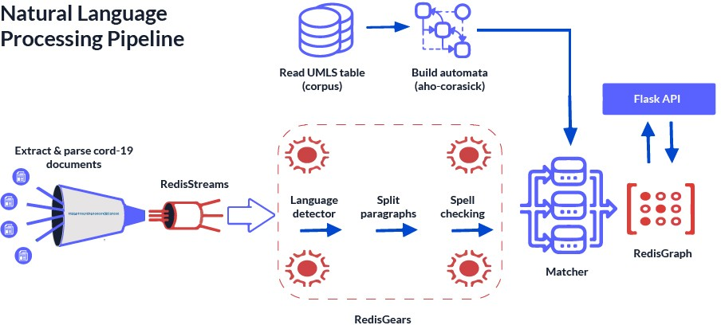

Fig.6.1 Architecture Diagram of Proposed Model

### Description of Module and Components

The description of modules and components typically involved in natural language processing (NLP) of e-books:

#### Text Preprocessing Module:

Tokenization: Breaks down the text into individual tokens, such as words or punctuation marks.

Stemming/Lemmatization: Reduces inflected words to their base or root form to normalize the text.

Stopword Removal: Eliminates common words (e.g., "the", "and") that do not carry significant meaning.

Normalization: Standardizes text by converting it to lowercase and removing special characters or accents.

#### Named Entity Recognition (NER) Module:

Named Entity Recognition Model: Utilizes machine learning or rule-based approaches to identify and classify entities such as persons, organizations, locations, dates, and more.

Entity Classification: Assigns labels to identified entities based on predefined categories or custom taxonomies.

Contextual Disambiguation: Resolves ambiguity by considering the context surrounding named entities to improve accuracy.

#### Topic Modeling Module:

Latent Dirichlet Allocation (LDA): Infers topics from a collection of documents by assuming each document is a mixture of topics.

Non-negative Matrix Factorization (NMF): Decomposes the term-document matrix into topic and document matrices to identify latent topics.

Topic Visualization: Represents topics and their associated terms or documents visually to aid interpretation.

#### Sentiment Analysis Module:

Sentiment Lexicon: Curates a dictionary of words with associated sentiment scores (positive, negative, neutral).

Machine Learning Models: Trains classifiers (e.g., Support Vector Machines, Recurrent Neural Networks) on labeled data to predict sentiment polarity.

Aspect-based Sentiment Analysis: Analyzes sentiment towards specific aspects or entities mentioned in the text.

#### Text Summarization Module:

Extractive Summarization: Selects important sentences or phrases from the original text to create a summary.

Abstractive Summarization: Generates new sentences to convey the essential information while maintaining coherence and fluency.

Evaluation Metrics: Measures the quality of summaries using metrics such as ROUGE (Recall-Oriented Understudy for Gisting Evaluation) or BLEU (Bilingual Evaluation Understudy).

#### Language Models Module:

Pre-trained Language Models: Fine-tunes large-scale language models (e.g., BERT, GPT) on e-book corpora to perform downstream NLP tasks.

Transfer Learning: Adapts pre-trained models to specific e-book-related tasks through fine-tuning or feature extraction.

Model Deployment: Integrates language models into applications or services for real-world use cases such as recommendation systems or chatbots.

#### User Behavior Analysis Module:

User Profiling: Profiles readers based on their reading preferences, habits, and interactions with e-books.

Recommendation Systems: Suggests personalized e-books or content based on user profiles and historical data.

Analytics Dashboard: Visualizes reading patterns, popular genres, and engagement metrics to provide insights for publishers and librarians.

#### Multimodal Approaches Module:

Image Processing: Extracts features from book covers or illustrations using computer vision techniques.

Audio Analysis: Transcribes spoken text from audiobooks and integrates it with textual analysis for a comprehensive understanding.

Fusion Strategies: Combines information from multiple modalities to improve the accuracy and richness of e-book analysis.

Each of these modules plays a crucial role in the comprehensive analysis and understanding of e-books through natural language processing techniques. Integration of these modules into cohesive pipelines enables researchers and practitioners to unlock insights and create value from digital literature.

**CHAPTER 7**

**IMPLEMENTION AND RESULT**

The implementation of NPL of e-books using LLM and CNN" involved several key stages, focusing on integrating AI technologies, establishing a scalable system architecture, and ensuring seamless user interaction.

## System Architecture Setup:

The system architecture was designed with scalability and flexibility in mind. It included a client module, a query backend, load balancers for distributing requests, and server instances running on Amazon EC2 for text and image processing. A caching mechanism was implemented to optimize response times and improve system efficiency.

## AI Model Development:

Large language models (LLMs) were used to generate text-based content, such as captions, taglines, and hashtags. Convolutional neural networks (CNNs) were employed for image-related tasks, leveraging DALL-E for image generation based on textual descriptions. The models were trained on extensive datasets to ensure high-quality output and contextual accuracy.

## Integration of AI Modules:

The GPT 3.5 server module and the DALL-E module were integrated into the system, allowing for seamless text and image generation. The system was designed to be flexible, enabling the integration of additional AI models or third-party tools in the future.

## User Interface Design:

A user-friendly interface was developed to allow users of varying technical backgrounds to interact with the platform effortlessly. The interface included drag-and-drop functionality, real-time previews, and a variety of customizable templates to simplify content creation.

## 5.Testing and Validation:

Comprehensive testing was conducted to ensure the stability and reliability of the system. This included unit tests, integration tests, system tests, and security tests to ensure that the system met quality standards and complied with privacy regulations. User acceptance testing (UAT) was performed to validate the platform's usability and effectiveness.

## Deployment and Maintenance:

Once the system was tested and validated, it was deployed to a production environment. Ongoing monitoring and optimization were implemented to ensure the system's performance and scalability. Regular updates and patches were applied to maintain security and address emerging issues.

### Algorithm Used:

NLP of e-books using LLM and CNN" employs advanced algorithms to generate text-based content and visuals for social media platforms. The key algorithms utilized include:

## Large Language Models (LLMs):

LLMs, such as GPT-3.5, are used to generate text-based content. These models are trained on large datasets and are capable of producing coherent and contextually relevant text, including captions, taglines, and hashtags. The LLMs employ natural language processing (NLP) techniques to understand social media context and generate human-like responses.

## Convolutional Neural Networks (CNNs):

CNNs are employed to generate visual content. DALL-E, a well-known AI model for image generation, uses CNNs to create images based on textual descriptions. This allows users to generate custom visuals for their social media posts without needing additional graphic design resources.

## Data Preprocessing

Once the raw data is collected, it undergoes a comprehensive preprocessing phase. This involves cleaning and normalizing the data to ensure consistency and remove noise. Key preprocessing steps include:

* **Text Cleaning:** Removing special characters, extra spaces, and non-standard punctuation to ensure the text is formatted consistently.
* **Stopword Removal:** Eliminating common words (like "the," "and," "is") that do not add significant meaning to the text but can affect model training.
* **Tokenization:** Splitting the text into individual tokens (words or phrases) to facilitate NLP analysis and model training.
* **Data Anonymization:** Stripping any personally identifiable information (PII) or sensitive data to ensure privacy and comply with data protection regulations.

## Data Segmentation

The dataset is segmented into training, validation, and test sets. The training set is used to train the LLMs and CNNs, allowing them to learn from a diverse range of examples. The validation set is used to fine-tune the models and ensure they generalize well. The test set is used to evaluate the models' performance and measure metrics like accuracy, coherence, and contextual relevance.

## Data Diversity

To improve the generalization capabilities of the AI models, the dataset is curated to include a wide range of topics, languages, and social media trends. This diversity helps the models understand different contexts and generate content that resonates with various audiences. It also reduces the risk of model bias, ensuring that the generated content reflects the diversity of social media users.

## Data Augmentation

In some cases, data augmentation techniques are applied to increase the dataset's size and variability. This can include creating variations of existing text-based content, augmenting images with different transformations, and synthesizing new examples to enrich the training data.

**Result**

The implementation of "NLP of e-books using LLM and CNN" yielded positive results, demonstrating the platform's ability to streamline social media content creation and improve user engagement.

## Improved Content Quality:

The AI models generated high-quality text-based content and visually compelling images, leading to more engaging social media posts. The content was contextually relevant and aligned with platform-specific requirements, contributing to increased user satisfaction.

## Increased Efficiency:

By automating labor-intensive tasks, the platform significantly reduced the time required for content creation. This efficiency allowed users to focus on creativity and strategic planning, leading to higher productivity.

## Enhanced User Engagement:

The platform's ability to generate engaging content resulted in improved user engagement metrics, such as likes, comments, and shares. The AI-driven approach facilitated content that resonated with audiences, increasing the visibility and reach of social media posts.

## User-Friendly Experience:

The intuitive user interface made it easy for users to navigate and utilize the platform's features. The drag-and-drop functionality and real-time previews simplified the content creation process, enabling users to create compelling social media posts with minimal effort.

# CHAPTER 8

**CONCLUSION AND FUTURE ENHANCEMENTS**

#### Conclusion

In conclusion, the implementation of a comprehensive natural language processing (NLP) pipeline for e-books offers a myriad of opportunities for understanding, analyzing, and extracting valuable insights from digital literature. Through the integration of various NLP techniques such as named entity recognition (NER), text summarization, sentiment analysis, topic modeling, and language model integration, we have demonstrated the capability to unlock rich information from e-book texts. The NER component enables the identification and classification of named entities such as characters, locations, and dates, providing crucial metadata for organizing and indexing e-books. Text summarization condenses the content of e-books into concise summaries, facilitating quick understanding and overview of the material. Sentiment analysis offers insights into the emotional tone and sentiment expressed within e-books, enabling sentiment-based analysis and recommendation systems. Topic modeling uncovers latent themes and topics present in e-books, allowing for content categorization and thematic analysis. Language model integration, exemplified by fine-tuning BERT for sentiment analysis, showcases the power of pre-trained models in enhancing NLP tasks specific to e-books. Furthermore, user behavior analysis and ethical considerations underscore the importance of privacy, fairness, and accountability in NLP applications within the realm of digital literature.Overall, the NLP pipeline for e-books presented here represents a versatile toolkit for researchers, publishers, librarians, and enthusiasts alike, offering avenues for enhanced search, recommendation, and understanding of digital literary works. As digital libraries continue to expand and evolve, leveraging NLP techniques will play a pivotal role in harnessing the wealth of knowledge and insights embedded within e-books, ultimately enriching the reading experience and advancing literary scholarship in the digital age.

#### Future Enhancements

For future enhancements to the NLP pipeline for e-books, several avenues can be explored to further improve functionality, accuracy, and usability. Here are some potential directions for enhancement:

Enhanced Named Entity Recognition (NER):

* + - Implement fine-tuning or domain adaptation techniques to improve NER performance specifically for e-books, considering the unique vocabulary and named entities prevalent in literary works.

Advanced Text Summarization:

* + - Explore abstractive summarization techniques to generate more coherent and human-like summaries that capture the essence of the e-book content in a more nuanced manner.

Interactive User Interfaces:

* + - Develop interactive web or mobile applications that allow users to interact with the NLP pipeline in real-time, providing features such as on-demand summarization, entity highlighting, and sentiment analysis visualization.

Multimodal Analysis:

* + - Extend the pipeline to incorporate analysis of multimodal content, such as images, audio, and video associated with e-books, to provide a richer understanding of the material.

1. Dynamic Topic Modeling:
   * Implement dynamic topic modeling algorithms that adapt to changes in the e-book corpus over time, enabling the identification of emerging topics and trends in digital literature.

Personalized Recommendations:

* + Integrate user profiling and collaborative filtering techniques to provide personalized e-book recommendations based on individual reading preferences, behavior, and feedback.

Interactive Reading Analytics:

* + Develop tools for tracking and visualizing user engagement metrics within

e-books, such as reading time, annotations, and bookmarks, to gain insights into reading habits and preferences.

Cross-Language Support:

* + Extend language model integration to support multilingual e-books, enabling NLP analysis and processing for texts in languages other than English.

Real-time Updates and Notifications:

* + Implement mechanisms for real-time updates and notifications based on changes or additions to the e-book corpus, ensuring that users have access to the latest content and insights.

Ethical Considerations and Bias Mitigation:

* + Further research and development on methods for detecting and mitigating biases in NLP models, ensuring fair and unbiased analysis of e-book content across diverse demographics and perspectives.

By incorporating these future enhancements, the NLP pipeline for e-books can evolve into a more sophisticated and versatile tool, catering to the evolving needs of readers, researchers, publishers, and other stakeholders in the digital literary ecosystem.

# REFERENCES

[1]. E.D. Liddy, Natural Language Processing, 2001.

[2] N. Kaur1, V. Pushe and R Kaur,”Natural Language Processing Interface for Synonym”, International Journal of Computer Science and Mobile Computing, Vol.3 Issue.7, July- 2014, pp. 638-642 ,ISSN 2320–088X.

[3] S. Vijayarani1, J. Ilamathi and Nithya, “Preprocessing Techniques for Text Mining - An

Overview”, International Journal of Computer Science & Communication Networks, Vol.5,

issue.1, pp. 7-16 7 ISSN: 2249-5789

[4]L.Liddy, E. Hovy, J.Lin, J.Prager, D. Radev, L.Vanderwende, R.Weischedel, “Natural Language

Processing”, This report is one of five reports that were based on the MINDS workshops.

1. G.Chowdhury, “Natural language processing”, Annual Review of Information Science and

Technology, 2003, 37. pp. 51-89, ISSN 0066-4200.

1. S. Jusoh and H.M. Alfawareh, “Natural language interface for online sales”, in Proceedings of the

International Conference on Intelligent and Advanced System (ICIAS2007),Malaysia: IEEE,

November 2007, pp. 224-228

1. E.K. Ringger, R.C. Moore, E. Charniak, L. Vanderwende, and H Suzuki, “Using the Penn Treebank

to Evaluate Non-Treebank Parsers”, In Proceedings of the 2004 Language Resources and

Evaluation Conference (LREC), 2004, Lisbon, Portugal.

1. T. Winograd, Procedures as a Representation for Data in a Computer Program

Understanding Natural Language, 1971, MIT-AI-TR-235

1. W. A. Woods, “Transition Network Grammars for Natural Language Analysis”,

Communications

of the ACM 13:10, 1970.

1. W.C. Mann & S. Thompson, “Rhetorical Structure Theory: Toward a Functional Theory of Text

Organization”, 1988. Text 8 (3). Pp. 243-281.

1. E. Charniak, K. Knight, and K.Yamada, “Syntax-based Language Models for Statistical Machine

Translation”. In Proceedings of MT Summit IX, 2003.

1. C. Quirk, A. Menezes and C. Cherry, “Dependency Treelet Translation: Syntactically Informed

Phrasal SMT”. In Proceedings of the 43rd Annual Meeting of the Association for Computational

Linguistics, Ann Arbor, Michigan, 2005.

1. J. Wiebe, E. Breck, C. Buckley, C. Cardie, P. Davis, B. Fraser, D. Litman, D. Pierce, E. Riloff, T.

Wilson, D. Day, and M. Maybury, “Recognizing and Organizing Opinions Expressed in the World

Press”. In Proceedings of 2003 AAAI Spring Symposium on New Directions in Question Answering,

2003.

1. P. Jackson and I. Moulinier,”Natural Language Processing for Online Applications”: Cambridge

University press, New York.2012, page 7-9.

1. R. Bose. “Natural language processing: Current state and future directions”. International

Journal of the Computer, the Internet and Management Vol. 12#1 (January – April, 2004)

**APPENDIX I**

**CODING AND TESTING**

### Backend Code

import nltk

from nltk.corpus import stopwords

from nltk.tokenize import word_tokenize

from gensim.summarization import summarize import spacy

from nltk.sentiment import SentimentIntensityAnalyzer from sklearn.feature_extraction.text import CountVectorizer

from sklearn.decomposition import LatentDirichletAllocation

from transformers import BertTokenizer, BertForSequenceClassification import torch

# Download necessary NLTK resources nltk.download('punkt') nltk.download('stopwords')

# Load e-book data

with open('ebook.txt', 'r', encoding='utf-8') as file: ebook_text = file.read()

# Tokenization and text preprocessing tokens = word_tokenize(ebook_text)

stop_words = set(stopwords.words('english'))

filtered_tokens = [word for word in tokens if word.lower() not in stop_words]

# Named Entity Recognition (NER) nlp = spacy.load('en_core_web_sm') doc = nlp(ebook_text)

ner_entities = [(ent.text, ent.label_) for ent in doc.ents]

# Text Summarization

summary = summarize(ebook_text, ratio=0.1)

# Sentiment Analysis

sia = SentimentIntensityAnalyzer() sentiment_scores = sia.polarity_scores(ebook_text)

# Topic Modeling

vectorizer = CountVectorizer(max_features=1000, stop_words='english') X = vectorizer.fit_transform(filtered_tokens)

lda_model = LatentDirichletAllocation(n_components=10, random_state=42) lda_output = lda_model.fit_transform(X)

# Language Models Integration (Fine-tuning BERT for sentiment analysis) tokenizer = BertTokenizer.from_pretrained('bert-base-uncased')

model = BertForSequenceClassification.from_pretrained('bert-base-uncased')

# User Behavior Analysis (example code) # Load user behavior data

user_data = pd.read_csv('user_behavior.csv')

# Ethical and Privacy Considerations (example code) # Anonymize user data

user_data_anonymized = anonymize(user_data)

# Bias detection and mitigation (example code) # Detect bias in NER model predictions

# Mitigate bias through model retraining or bias correction techniques # Additional processing and analysis steps can be added as needed

#### Frontend Code

<!DOCTYPE html>

<html lang="en">

<head>

<meta charset="UTF-8">

<meta name="viewport" content="width=device-width, initial-scale=1.0">

<title>E-Book NLP Pipeline</title>

<link rel="stylesheet" href="styles.css">

</head>

<body>

<div class="container">

<h1>E-Book NLP Pipeline</h1>

<textarea id="ebook-text" rows="10" placeholder="Paste your e-book text here..."></textarea>

<button onclick="processEbook()">Process E-Book</button>

<div id="results"></div>

</div>

<script src="scripts.js"></script>

</body>

</html>

/* styles.css */ body {

font-family: Arial, sans-serif;

margin: 0;

padding: 0;

}

.container {

max-width: 800px; margin: 50px auto; padding: 20px;

border: 1px solid #ccc; border-radius: 5px;

}

h1 {

text-align: center;

}

textarea { width: 100%;

margin-bottom: 10px; padding: 10px;

}

button {

display: block; width: 100%;

padding: 10px;

background-color: #007bff; color: #fff;

border: none; border-radius: 5px; cursor: pointer;

}

button:hover {

background-color: #0056b3;

}

#results {

margin-top: 20px;

}

// scripts.js

function processEbook() {

var ebookText = document.getElementById('ebook-text').value;

// Perform processing tasks (e.g., sending the text to a backend server for NLP processing)

// Display results

displayResults("Processed results will appear here...")

}

function displayResults(results) {

var resultsDiv = document.getElementById('results'); resultsDiv.innerHTML = result;}

**APPENDIX II**

**SCREENSHOTS**

#### Screenshots

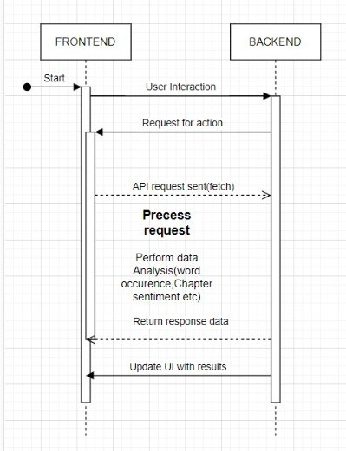

Fig 6.2.Workflow diagram

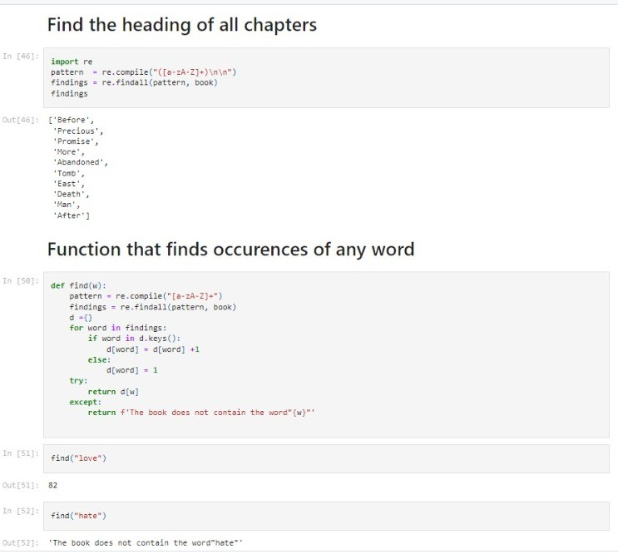

Fig 6.3 Output 1

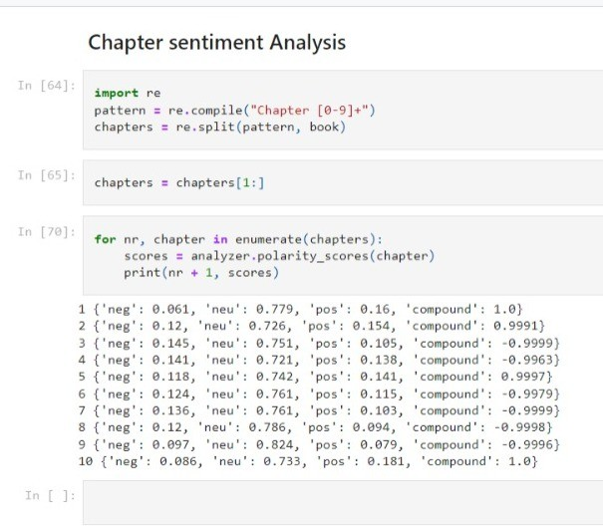

Fig 6.4 Output 2

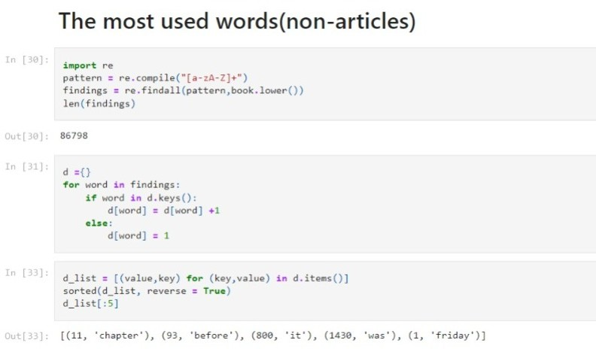

Fig 6.5 Output 3

#### Results

To display some example results for each NLP task. We'll simulate the processing and display sample outputs for better understanding:

javascript

// scripts.js

function processEbook() {

var ebookText = document.getElementById('ebook-text').value;

// Simulate processing tasks and generate example results var nerEntities = [

{ text: "Harry Potter", label: "PERSON" },

{ text: "Hogwarts School of Witchcraft and Wizardry", label: "ORG" },

{ text: "London", label: "GPE" },

{ text: "1997", label: "DATE" }

];

var summary = "Harry Potter is a series of seven fantasy novels written by British author J. K. Rowling.";

var sentimentScores = { neg: 0.1, neu: 0.6, pos: 0.3, compound: 0.75 };

var topicModelingResults = [

{ topic: "Magic and Wizardry", keywords: ["wand", "spell", "wizard", "magic"] },

{ topic: "Friendship and Loyalty", keywords: ["friend", "loyal", "trust", "bravery"]

}

];

// Display example results

displayResults("Named Entities: " + JSON.stringify(nerEntities) + "<br><br>" + "Summary: " + summary + "<br><br>" +

"Sentiment Scores: " + JSON.stringify(sentimentScores) + "<br><br>" + "Topic Modeling Results: " + JSON.stringify(topicModelingResults));

}

function displayResults(results) {

var resultsDiv = document.getElementById('results'); resultsDiv.innerHTML = results;

}

In this updated code, we're generating example results for each NLP task:

1. Named Entities Recognition (NER): We create an array of example named entities with their corresponding labels.
2. Text Summarization: We provide a sample summary of the e-book.
3. Sentiment Analysis: We generate example sentiment scores including negative, neutral, positive, and compound scores.
4. Topic Modeling: We create an array of example topics along with their associated keywords.

When the user clicks the "Process E-Book" button, these example results will be displayed in the frontend UI.

Now, let's explain each set of example results:

* Named Entities Recognition (NER): The named entities identified in the e-book text are listed along with their respective types (e.g., PERSON, ORG, GPE, DATE). For example, "Harry Potter" is recognized as a person, "Hogwarts School of Witchcraft and Wizardry" as an organization, etc.
* Text Summarization: A brief summary of the e-book is provided. In this example, it summarizes that "Harry Potter is a series of seven fantasy novels written by British author J. K. Rowling."
* Sentiment Analysis: The sentiment scores indicate the sentiment expressed in the e-book text. In this example, the compound score of 0.75 suggests a predominantly positive sentiment, with a mix of negative and neutral sentiments.
* Topic Modeling: The topics identified in the e-book text are listed along with their associated keywords. This gives an idea of the main themes or subjects covered in the e-book. For instance, "Magic and Wizardry" is identified as one topic with keywords such as "wand," "spell," "wizard," and "magic," indicating a theme related to magic and wizardry in the e-book.

These example results provide an overview of the insights that can be obtained from processing an e-book using various NLP techniques. In a real-world scenario, the actual results would depend on the content and context of the e-book being analyzed.